

**Space for School Festival**

**Software Requirement Specification**

2021.10.31

**Introduction to Software Engineering 41**

**TEAM 16**

Team Leader Hyejin Yoon

Team Member Gyeongun Kang

Team Member Jeongbok An

Team Member Seunggu Kang

Team Member Soo Namgoong

Team Member Yuyeong Seo

**CONTENTS**

1. Introduction 7

1.1. Purpose 7

1.2. Scope 7

1.3. Definitions, Acronyms, and Abbreviations 7

1.4. References 8

1.5. Overview 9

2. Overall Description 9

2.1. Product Perspective 9

2.1.1. System Interfaces 9

2.1.2. User Interfaces 9

2.1.3. Hardware Interfaces 10

2.1.4. Software Interfaces 10

2.1.5. Communication Interfaces 10

2.1.6. Memory Constraints 10

2.1.7. Operations 10

2.1.7.1. System Administrator 10

2.1.7.2. User 10

2.2. Product Functions 11

2.2.1. Register 11

2.2.2. Get User Preferences 11

2.2.3. Action 12

2.2.4. Stages 12

2.2.5. Audience 12

2.2.6. Exhibition booth 12

2.2.7. Photo & Video shooting 13

2.2.8. Information Desk 13

2.3. User Characteristics 13

2.3.1. System Administrator 13

2.3.2. User 13

2.3.3. Vendor 13

2.4. Constraints 14

2.5. Assumptions and Dependencies 14

3. Specific Requirements 15

3.1. External Interface Requirements 15

3.1.1. User Interfaces 15

3.1.2. Hardware Interfaces 20

3.1.3. Software Interfaces 21

3.1.4. Communication Interfaces 21

3.2. Functional Requirements 22

3.2.1. Use Case 22

3.2.2. Use Case Diagram 28

3.3. Performance Requirements 28

3.3.1. Static numerical requirement 29

3.3.2. Dynamic numerical requirement 29

3.4. Design Constraints 29

3.5. Standards compliance 29

3.6. Software System Characteristics 30

3.6.1. Product Requirements 30

3.6.1.1. Usability Requirements 30

3.6.1.2. Efficiency Requirements 30

3.6.1.3. Dependability Requirements 30

3.6.1.4. Security Requirements 30

3.6.2. Organizational Requirements 31

3.6.2.1. Organizational Requirements 31

3.6.2.2. Environmental Requirements 31

3.6.3. External Requirements 31

3.6.3.1. Safety/Security Requirements 31

3.6.3.2. Regulatory Requirements 31

3.7. Organizing the Specific Requirement 31

3.7.1. Context Model 31

3.7.2. Process Model 32

3.7.3. Interaction Model 33

3.8. System Architecture 33

3.9. System Evolution 34

3.9.1. Limitation and Assumption 34

3.9.2. Evolutions of Hardware 34

4. Supporting information 34

4.1. Software Requirement Specification 35

4.2. Document History 35

**LIST OF FIGURES**

[Figure 1] Use Case Diagram 28

[Figure 2] Context Model 32

[Figure 3] User Process Model 32

[Figure 4] Administer Process model 33

[Figure 5] MVC Pattern 34

**LIST OF TABLES**

[Table 1] Table of definitions of terms 7

[Table 2] Table of acronyms and abbreviations 8

[Table 3] User interface of VRChat world 15

[Table 4] User interface of stage 16

[Table 5] User interface of Backstage 17

[Table 6] User interface of seats 18

[Table 7] User interface of screen 18

[Table 8] User interface of booth 19

[Table 9] Hardware interface of the device capable of running VRChat 20

[Table 10] Software interface of VRChat 21

[Table 11] Communication interface of user and VRChat server 21

[Table 12] Use case of Register 22

[Table 13] Use case of Log-in/out 23

[Table 14] Use case of Settings 24

[Table 15] Use case of Actions 24

[Table 16] Use case of Network Objects 25

[Table 17] Use case of Voice Chatting 26

[Table 18] Use case of Upload World 26

[Table 19] Use case of Open World 27

[Table 20] Document History 35

1. Introduction

## **Purpose**

This document is a Software Requirement Specification for the service of Space for School Festival. The requirements for this service are organized, analyzed, and documented to this document. Based on the document, Team 16 of the Introduction to Software Engineering at Sungkyunkwan University design and implement this service.

This document describes the overall requirements for service to host school festivals online by VRChat. The main readers of this document are students, TAs and professor at Introduction to Software Engineering at Sungkyunkwan University. And if this system is developed as a product in the future, all employees of related companies and anyone who will use the services can become additional readers.

## **Scope**

The service of Space for School Festival allows users to enjoy the online festival for those who are unable to enjoy the offline festival due to COVID-19. Through this service, users can enjoy and organizer of school festival can host an online festival with various booths, stages, and events. The system is developed on the basis of Unity and served through VRChat.

## **Definitions, Acronyms, and Abbreviations**

The following tables are about definitions, acronyms, and abbreviations of terms used in the document. The first table explains definitions of terms that may be unfamiliar to the reader and the second table explains the acronyms, and abbreviations.

[Table 1] Table of definitions of terms

|  |  |
| --- | --- |
| Term | Definition |
| User | The person who uses the service |
| System administrator | The person who operates and maintains a computer system |
| Vendor | The company that provides goods or service |
| Software | Program that runs and is used on a computer |
| Hardware | The mechanical devices that make up a computer |
| Open Source software | Code designed to be publicly accessible so that anyone can freely view, modify, and distribute it |
| Unity | The game engine providing development equipment of 3D and 2D video game |
| Asset | In Unity, all elements needed to make a game |

[Table 2] Table of acronyms and abbreviations

|  |  |
| --- | --- |
| Acronyms  Abbreviations | Explanation |
| VR | Virtual Reality |
| RAM | Random Access Memory |
| CPU | Central Processing Unit |
| GTX | Grand eXtreme Edition |
| OS | Operating System |
| COVID-19 | Corona, Virus, Disease, 2019 |
| PC | Personal Computer |
| SDK | Software Development Kit |
| ID | Identification |

## **References**

* IEEE Std 830-1998 IEEE Recommended Practice for Software Requirements Specifications, In IEEEXplore Digital Library  
  http://ieeexplore.ieee.org/Xplore/guesthome.jsp
* Team 1. “SRS_TEAM1”. SKKU, Last Modified: May 14, 2020.  
  https://github.com/skkuse/2020spring_41class_team1/blob/master/docs/SRS_TEAM1.pdf
* VRChat Documentation.  
  https://docs.vrchat.com/
* Introduction to Software Engineering. “5. Requirements Engineering(new)”. EunSeok Lee, Last Modified: October 11, 2021.

## **Overview**

This document consists of 4 chapters including the current chapter. The second chapter describes the Overall Description. This chapter covers product perspective on interfaces, Function provided by the product, characteristics of system administrator, user, and vendor of the product, constraints, and assumptions and dependencies. The third chapter is about Specific Requirements. It deals with requirements such as external interface requirements, functional requirements that cover use cases, and performance requirements. This chapter also covers non-functional requirements such as security requirements, and system architecture. The last chapter is about Supporting Documentation. It includes supporting documentation as well as document history.

1. Overall Description

## **Product Perspective**

This product is designed to hold a school festival at a time when COVID-19 forced them to gather online. This application will bring joy that has not been felt for a while through various booth experiences, stage viewing, and events. This application provides useful or interesting content to participants in the booth. Even if a person does not participate in the booth, a person can watch the stage on the main stage and participate in the raffle event.

### **System Interfaces**

All user information, user activities, and communication are carried out through VRChat. The user's information are stored in the VRChat’s variable which contains 3D positions and set of colors, and the informations of the object movements are stored in the VRChat’s event. All users are network objects and are connected to the host user's network object to exchange data.

### **User Interfaces**

A festival space is provided through the screen of the desktop, and user can select what to do and what to watch through avatar. Users can see what the avatar is watching through the screen, voice chat with other users through a microphone, and moving the avatar’s hands and feet through the manipulation of the keyboard and mouse.

The administrator can make booth content, main stage schedule, and raffle event. The administrator is provided with an interface through the Unity, and supports registration, deletion, maintenance, and management of festival content.

### **Hardware Interfaces**

The system is intended for desktop device. The Desktop must have at least 4GB RAM, i5-4590 / FX 8350 CPU, and GTX 970 / Radeon R9 graphic card.

### **Software Interfaces**

The system is intended for Windows OS version is Windows 7, Windows 8.1, Windows 10. DirectX version 11 is needed at least

### **Communication Interfaces**

User device and server communicate with VRChat.

### **Memory Constraints**

The system should run on desktop devices with least 4GB RAM for primary memory and the system requires at least 1GB for installation and execution

### **Operations**

#### System Administrator

* + Management festival content
    - The overall structure of the festival space was designed by the system administrator
    - Decide what content will be carried out in the booth
    - Schedule what stage and raffle events will be held on the main stage

#### User

* + Participate festival
    - Users can go around the festival space, chat with others, and take pictures
  + Experience booth
    - Users can enjoy a game with others or alone
    - Users can enjoy a speed quiz and challenge for ranking
    - User can join stamp tour that visit each booth, join the contents of each booth, can get a stamp for reward
    - Users can get vehicle
  + Enjoy the stage
    - User can enjoy the other’s performance stage
    - User can check the schedule of the festival
    - Users can purchase products at a low price through a lottery through the raffle event held every specific time

## **Product Functions**

### **Register**

In order for users to use the application, they must create an account on the VRChat web page in advance and register it with the system. After that, user can download the application and log in to access the application. Account creation is possible through sign-up button, filling the information required by the user and checking the content box. The required information includes user name, email address, password, date of birth, etc. If the account is strong like this, user can finally verify the account through email verification and complete the registration.

### **Get User Preferences**

User can download Unity and SDK after logging in and entering VRChat. A total of four files are required for avatar registration, including Unity, SDK, avatar file, and cube. For avatar setting, after importing the SDK to Unity, press the VRChat SDK to enter the setting and log in to the VRChat account currently playing. Then, put the cube and avatar file into Assets. After putting all four files in the Asset, double-click the avatar file and double-click open me, which is the Unity icon. Next, press VRChat SDK again to select Build & Public. If user waits a little bit, user can set up a new avatar. Users can modify avatar, audio, voice, convenience and safety options to suit their individuals. Before personalization, user will support the default settings provided by VRChat and the most basic avatar.  
After logging in, users can set their profiles and game environments as they want. These system setting pages are accessible from Menu through setting button, and the avatar setting pages are similarly accessible by selecting Avatar from Menu.

### **Action**

After setting user preferences, several actions may be performed. Users can communicate through Voice Chatting and explore the world by moving their avatars. Users can interact with registered users in the world and enjoy a variety of content and festival events. Contents that users can enjoy include Festival Stage, Backstage, Audience, Screen, Exhibition Boot, Photo & Video Shooting, and Information Desk.

### **Stages**

World offers Festival Stage, Backstage, and screens behind the stage. In the Festival Stage, the host user hosts events for users. Users can receive gifts through a prize lottery, and in addition, various main stages will be held on the stage. While the Festival stage is resting for a while, the stage is covered through the screen. The screen is divided into main screen and two sub screens. Main screen is in charge of relaying or replacing the stage, and sub screen shares the schedule. Backstage is a place used by stage participants to prepare. Participants check their conditions there and wait for the stage.

### **Audience**

Users can interact with chairs installed in the middle of the festival space to see the stage and screen. Also, users can interact with drinks, pens, and cushions on the table while participating in the booth or visiting the information desk.

### **Exhibition booth**

Users can enjoy four types of booths. First, users can participate in the quiz booth to get various quizzes within the time limit and challenge the ranking competition. Second, users can enjoy simple games such as bowling or beer-pong. Third, users can get vehicle from a specific booth. Finally, after experiencing each booth, stamp is stamped, and after experiencing all booths, collecting stamps, and users can visit the booth to receive prizes.

### **Photo & Video shooting**

Users can freely take pictures or take videos during the event through a camera installed in the world.

### **Information Desk**

Users can visit the information desk during the festival to receive information brochure on how the festival is organized, and learn about the type and schedule of the event.

## **User Characteristics**

### **System Administrator**

System administrators are limited to those who have contributed to designing and building the system themselves. Therefore, the system administrator has sufficient ability to handle system problems, and the system administrator may have majored in computer science or similar studies, or is qualified to become a network administrator or system administrator. In addition, system administrators should be able to actively cope with applications when errors occur, and to reflect users' requirements additionally and quickly. To this end, the system administrator must be familiar with Unity, the development environment of the application.

### **User**

The users commonly mentioned in this document are students of the software department of Sungkyunkwan University. It is assumed that users have been stressed out by limited school events due to two years of COVID-19, and are therefore willing to actively participate in online events. Suppose that users are familiar with using computer devices, have experience using VRChat, and therefore have the ability to communicate with people and play games without any inconvenience within the VRChat platform. Any software student can use the user, but in some functions, the user can be narrowed down to enrolled students.

### **Vendor**

Vendor is a VRChat platform company. The VRChat platform enables users to use the application freely, and mounts and services basic functions, including servers and databases. Users can start VRChat through the platform's web page. VRChat provides and supplies that function to users through applications such as Steam, Quest, Rift, and Viveport.

## **Constraints**

This system will be designed and implemented based on what is mentioned in this document. Other details are designed and implemented by selecting the direction preferred by the developer, but they comply with the following.

* + Note that users sit, stand, or participate in room scale mode.
  + Network traffic should not occur in an environment where multiple users access at the same time.
  + Do not use functions that require additional charges.
  + To improve overall system performance.
  + Consider it in an easier and more convenient way to use.
* Use open source software as much as possible
* Considering system cost and maintenance cost.
  + Consideration of future scalability and availability of systems
  + Optimize the source code to prevent waste of system resources.
* Consider future maintenance and add sufficient comments when writing source code.
  + Test operation of the system using the steam of the window version 10 operating system.

## **Assumptions and Dependencies**

All systems in this document were created on the assumption that they were designed and implemented on a PC basis. In order to use the application, 724.9MB of free space is required for that PC and no separate VR device is required. In addition, the system was implemented based on the updated version in March 2021, and may not apply to other operating systems or versions as it is created based on the Windows operating system.

1. Specific Requirements

## **External Interface Requirements**

### **User Interfaces**

[Table 3] User interface of VRChat world

| **Name** | **VRChat world Interface** |
| --- | --- |
| Purpose/Description | Using VRChat world as a space for a school festival, users enter the world and interact with other users and objects in VRChat |
| Input source/  Output destination | User / User device capable of running VRChat |
| Range/  Accuracy/  Margin of error | Depends on VRChat |
| Unit | VRChat running window |
| Time/ Velocity | After entering the world / Depends on processing time of the user device and communication time between the user device and VRChat server |
| Relationship with other input/outputs | User input affects the user's position and the state of objects in the world |
| Format and configuration | <Upper side view of world>    1. VRChat running window of the user who entered the world is connected to unity scene composed of unity objects  2. Users interact with other users and objects through VRChat |
| Data type | Unity object |
| Instruction type | N/A |
| Exit message | N/A |

[Table 4] User interface of stage

| **Name** | **Stage Interface** |
| --- | --- |
| Purpose/Description | Stage is a space where performers perform, host proceeds festival and lottery event |
| Input source/  Output destination | User / Objects composed of stage |
| Range/  Accuracy/  Margin of error | Depends on VRChat |
| Unit | Unity object |
| Time/ Velocity | After entering the world / Depends on processing time of the user device and communication time between the user device and VRChat server |
| Relationship with other input/outputs | Appearance of the stage is related to the output of the screen  Amplification of the voice output through the microphones on the stage is related to other user's voice input |
| Format and configuration | <Stage>    1. Stage is composed of unity objects  2. Curtain can be opened and closed the stage  3. Microphones on stage can deliver louder voice to the users |
| Data type | Unity object |
| Instruction type | N/A |
| Exit message | N/A |

[Table 5] User interface of Backstage

| **Name** | **Backstage Interface** |
| --- | --- |
| Purpose/Description | Backstage is a space where performers prepare for performance and check their avatars through the mirror |
| Input source/  Output destination | User / Objects composed of backstage |
| Range/  Accuracy/  Margin of error | Depends on VRChat |
| Unit | Unity object |
| Time/ Velocity | After entering the world / Depends on processing time of the user device and communication time between the user device and VRChat server |
| Relationship with other input/outputs | N/A |
| Format and configuration | <Backstage>    1. Backstage is composed of unity objects  2. User can check the appearance and behavior of the user's own avatar through the mirror |
| Data type | Unity object |
| Instruction type | N/A |
| Exit message | N/A |

[Table 6] User interface of seats

| **Name** | **Seats Interface** |
| --- | --- |
| Purpose/Description | Users sit on chairs and watch the stage |
| Input source/  Output destination | User / Objects composed of seats |
| Range/  Accuracy/  Margin of error | Depends on VRChat |
| Unit | Unity object |
| Time/ Velocity | After entering the world / Depends on processing time of the user device and communication time between the user device and VRChat server |
| Relationship with other input/outputs | N/A |
| Format and configuration | <Seats>    1. Seats are composed of unity objects  2. User can interact with the chair to make user’s own avatar sit on the chair |
| Data type | Unity object |
| Instruction type | N/A |
| Exit message | N/A |

[Table 7] User interface of screen

| **Name** | **Screen Interface** |
| --- | --- |
| Purpose/Description | Screen broadcasts the stage or video to users and displays the schedule |
| Input source/  Output destination | Objects composed of screen / User device |
| Range/  Accuracy/  Margin of error | Depends on VRChat |
| Unit | Unity object |
| Time/ Velocity | After entering the world / Depends on processing time of the user device and communication time between the user device and VRChat server |
| Relationship with other input/outputs | The output of the screen is related to the appearance of the stage |
| Format and configuration | <Screen>    1. Screen is composed of unity objects  2. Screen is divided into three, the stage or other video want to play is broadcast in the middle, and the festival schedule is displayed on both sides |
| Data type | Unity object |
| Instruction type | N/A |
| Exit message | N/A |

[Table 8] User interface of booth

| **Name** | **Booth Interface** |
| --- | --- |
| Purpose/Description | In each booth, users perform unique activities for that booth |
| Input source/  Output destination | User / Objects composed of booth |
| Range/  Accuracy/  Margin of error | Depends on VRChat |
| Unit | Unity object |
| Time/ Velocity | After entering the world / Depends on processing time of the user device and communication time between the user device and VRChat server |
| Relationship with other input/outputs | Activities in booth can related to activities in other booths |
| Format and configuration | <Booth>    1. Booth is composed of unity objects  2. In the booth, users can participate the activities prepared by each booth and activity of each booth can consist of interactions between users and booth-related objects  3. Booth wall screens display contents related to the booth, such as the booth title, promotion, description, or activity |
| Data type | Unity object |
| Instruction type | N/A |
| Exit message | N/A |

### **Hardware Interfaces**

[Table 9] Hardware interface of the device capable of running VRChat

| **Name** | **Device capable of running VRChat** |
| --- | --- |
| Purpose/Description | Enable users to open or join the VRChat world /  Processor: Intel® i5-4590 / AMD FX 8350 equivalent or greater  Memory: 4 GB RAM  Graphics: NVIDIA GeForce® GTX 970 / AMD Radeon™ R9 290 equivalent or greater  Storage: 1 GB available space |

### **Software Interfaces**

[Table 10] Software interface of VRChat

| **Name** | **VRChat** |
| --- | --- |
| Purpose/Description | Platform for simultaneous access to the world with multiple users |
| Input source/  Output destination | VRChat server / User device  User / VRChat server |
| Range/  Accuracy/  Margin of error | Depends on the performance of VRChat |
| Unit | Unity object |
| Time/ Velocity | After entering the world / Depends on processing time of the user device and communication time between the user device and VRChat server |
| Relationship with other input/outputs | Relates to all inputs/outputs occurred in the world of VRChat |
| Format and configuration | N/A |
| Data type | Unity object |
| Instruction type | N/A |
| Exit message | N/A |

### **Communication Interfaces**

[Table 11] Communication interface of user and VRChat server

| **Name** | **User and VRChat server** |
| --- | --- |
| Purpose/Description | User requests world open and access to VRChat server, and sends interaction information inside the world to the server  VRChat server processes interactions between users or between user and network objects in VRChat world and reflects them in the world |
| Input source/  Output destination | VRChat server / User  User / VRChat server |
| Unit | packet |
| Time/ Velocity | Broadband Internet connection required |
| Relationship with other input/outputs | Relates to all inputs/outputs occurred in the world of VRChat |
| Format and configuration | N/A |
| Data type | Unity object |
| Instruction type | N/A |
| Exit message | N/A |

## **Functional Requirements**

### **Use Case**

[Table 12] Use case of Register

|  |  |
| --- | --- |
| **Use case name** | **Register** |
| Actor | Unregistered user |
| Description | It is a process when unregistered user tries to register in VRchat as a member to use the available functions of the system.  * It is the function that already exists in VRChat. |
| Normal Course | 1. When user runs VRChat, there are log-in and sign-up button  2. User clicks sign-up button  3. User fills the required information, checks the consent box, and click create account button  - User name  - Email address  - password  - birth  4. Email verification  5. New user is registered |
| Precondition | The user is not registered to the system yet  The user enters correct information  The same email address should not be overlapped with that of other users  In case of incorrect inputs, the system validates the form of email address and password |
| Post Condition | The password should be encrypted and saved to the server database for security |
| Assumptions | N/A |

[Table 13] Use case of Log-in/out

|  |  |
| --- | --- |
| **Use case name** | **Log-in/out** |
| Actor | Registered user |
| Description | <Log-in>  It is a process that a registered user of the system tries to access to the system to use available service of the system  <Log-out>  It is a process that a registered user of the system tries to get out of the system  * It is the function that already exists in VRChat. |
| Normal Course | <Log-in>  1. When user gets into the system, the user chooses the log-in method  2.1 VRChat Log-in  - Input user name and password  2.2 Steam Log-in  - Input birth date and do account verification  3. If the input value is correct, user can get into the system and use the available service of the system  <Log-out>  When user wants to get out of the system, user click the log-out button of the menu in VRchat |
| Precondition | <Log-in>  The user should already be registered to the system  <Log-out>  The user should be in a logged-in status. |
| Post Condition | <Log-in>  The user should be connected to network  <Log-out>  The user logged out and a log-in window appears again for new log-in session |
| Assumptions | N/A |

[Table 14] Use case of Settings

|  |  |
| --- | --- |
| **Use case name** | **Settings** |
| Actor | Registered user |
| Description | It is a process that user can set his/her own profile or adjust game settings. User can change the avatar and change audio, voice, comfort and safety options.  * It is the function that already exists in VRChat. |
| Normal Course | User calls menu with specific key input (ex. ESC in desktop mode)  <Game settings>  1. Click Settings button in Menu  2 Adjust game settings as user wishes  <Change avatar>  1. Click Avatar in Menu  2 User can change the avatar provided by default or provided in a world |
| Precondition | The user should be in a logged-in status and connected to network |
| Post Condition | N/A |
| Assumptions | N/A |

[Table 15] Use case of Actions

|  |  |
| --- | --- |
| **Use case name** | **Actions** |
| Actor | Registered user |
| Description | It is a process when user interacts with the objects in the world and join contents of festival events. There are various contents that users can enjoy in a world. |
| Normal Course | <Festival Stage>  1. Performer users perform performance and host user progress the event  2. Users open lottery event for gift  3. When the stage is empty for next stage, cover the stage with screen such as curtain  <Backstage>  1. Participant users can check their status using mirror while users waiting for stage  2. Participant users can change their avatars  <Audience>  1. User can interact with chair to sit and watch stages and screen  2. User can interact with objects such as drinks, pen, and cushion on the table  <Screen>  Screens are divided into three, one for main screen to show stage, two for sub screens to show time and festival schedule  <Exhibition booth>  1. User can join stamp tour that visit each booth, join the contents of each booth, can get a stamp for reward  2. User can join a quiz booth and challenge for ranker  3. User can join simple games such as baseball, bowling, or beer pong  4. User can get vehicle from a specific booth  <Photo & Video Shooting>  User can shoot a photo or video using camera installed in the world  <Information Desk>  User can get information brochure about the school festival event from information desk |
| Precondition | The user should be in a logged-in status and connected to network  The user should be invited to private world or join the public world |
| Post Condition | Network objects synchronized for every user in world |
| Assumptions | N/A |

[Table 16] Use case of Network Objects

|  |  |
| --- | --- |
| **Use case name** | **Network Objects** |
| Actor | System |
| Description | It is a process when user interacts with the network object, object information is synchronized to all users in the world. |
| Normal Course | <Screen>  As time goes by, system delete schedules that have already passed from the list.  <Exhibition Booth>  According to the game results, system updates the ranking of users in real time. |
| Precondition | The user should be in a logged-in status and connected to network.  The user should be invited to world and join the world.  User interacts with the network object in world |
| Post Condition | Data of network object should be updated |
| Assumptions | N/A |

[Table 17] Use case of Voice Chatting

|  |  |
| --- | --- |
| **Use case name** | **Voice** |
| Actor | Registered user |
| Description | Users can communicate with each other by voice chatting  * It is the function that already exists in VRChat. |
| Normal Course | 1. User speaks, and mic catch user’s voice and send  2. User can mute voice |
| Precondition | The user should be in a logged-in status and connected to network.  The user should be invited to world and join the world. |
| Post Condition | N/A |
| Assumptions | N/A |

[Table 18] Use case of Upload World

|  |  |
| --- | --- |
| **Use case name** | **Upload World** |
| Actor | Administrator |
| Description | It is a process when a user become a “User” in safety, user can upload his/her own world to community labs. If it passes verification, it becomes a public world. User can check the uploaded world through the browser.  * It is the function that already exists in VRChat. |
| Normal Course | 1. Setting up a scene  2. Creating spawn points  3. Descriptor Settings  4. Setting up the Scene  5. Build up world and upload on community labs  6. Verification |
| Precondition | N/A |
| Post Condition | Administrator gets the permission to open world which is uploaded. |
| Assumptions | N/A |

[Table 19] Use case of Open World

|  |  |
| --- | --- |
| **Use case name** | **Open World** |
| Actor | Administrator |
| Description | It is a process that user sets world to public so that anyone can enter the world or sets world to private so that the other users who were invited can only enter the world.  * It is the function that already exists in VRChat. |
| Normal Course | 1. User chooses world to open  2. User clicks new instance and set privacy bounds – public or invite |
| Precondition | The world should be already uploaded. |
| Post Condition | The condition status of world in server updated – public or private. |
| Assumptions | N/A |

### **Use Case Diagram**

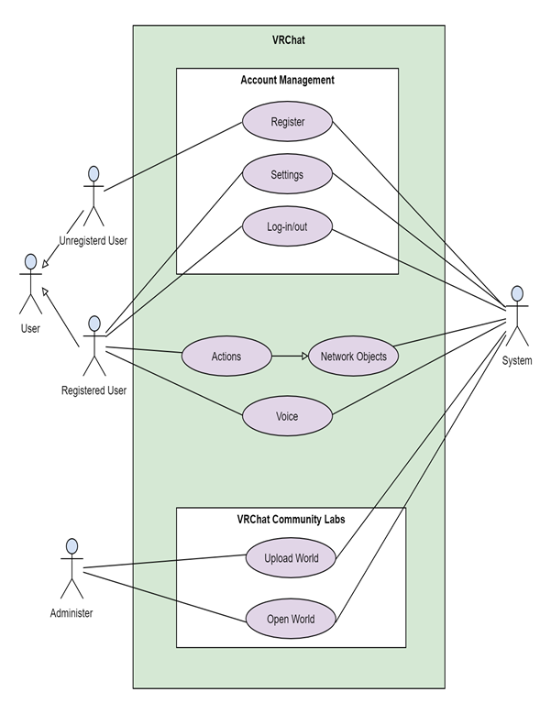

[Figure 1] Use Case Diagram

## **Performance Requirements**

The following performance requirement is described by predicting the numerical value of the system performance.

### **Static numerical requirement**

* The system only supports one concurrent user for each PC and Steam account and does not allow multiple connections on one PC.
* The system should run smoothly on a PC device with at least 4GB of RAM and an intel i5-4590, AMD FX 8350 or higher processor, Direct Version 11.
* The system supports VRChat version 2021.3.3p2

### **Dynamic numerical requirement**

* The system runs smoothly for around 50, up to 80 concurrent users.
* The login process should be completed within 2 seconds.
* Accessing service should run within 10 seconds.
* Entering World should run within 12 seconds.
* Ranking should be updated within 10 seconds.
* Opening and Closing curtain should be displayed within 3 seconds after executing it.
* In booth, setting should be reset within 2 seconds for the new game.

## **Design Constraints**

This system should be designed with care in application to VRChat. All components placed in the world of the system must comply with performance guidelines, such as satisfying the optimization criteria, presented by VRChat, and include only components that can be distributed under the MIT license. It should also be accessible from various PCs. Variables and functions should be named appropriately and understandable for their function, and should include comments to facilitate cooperation with team members.

## **Standards compliance**

All programs in the system are written according to the VRChat Udon which is developed by VRChat developers and the rest follows the existing programming techniques. The system's world map management must be accessed through Unity.

## **Software System Characteristics**

By explaining Non-functional involving product, organizational, and external requirements, software system characteristics can be shown. Product requirements specify that the delivered product must behave in a particular way such as execution speed and reliability. Organizational requirements are a consequence of organizational policies and procedures. External requirements arise from factors which are external to the system and its development process.

### **Product Requirements**

#### Usability Requirements

The system should be easy to use by user and should be organized in such a way that user errors are minimized. The user interface should be simple and intuitive to make it easy to use all the functions without a separate manual, and it should be easy to understand the purpose of the place by arranging objects with functions that fit the purpose of the place.

#### Efficiency Requirements

Since many users are accessing at the same time, the system needs to optimize the script for the function so that the system doesn't spend a lot of time synchronization and loading.

#### Dependability Requirements

The system's ranking system and lottery system must be trusted by users. In the ranking system, if a user's score is omitted or incorrectly displayed, and a lottery system in which all numbers are not equally probable is not allowed.

#### Security Requirements

Administrators can access administrator rights by registering administrator rights after proper authentication. It should prevent unauthorized users from accessing the system managing and information involving privacy. Before using the system, the user must log in to VRChat to authenticate the user and authenticate the affiliation through the guestbook.

### **Organizational Requirements**

#### Organizational Requirements

The objects that make up the place in the world of the system and the objects that will perform their functions are imported and depended on the ‘unity asset store’. Objects with various appearances and functions are stored, and some of them can be used for free.

#### Environmental Requirements

System users must identify themselves via steam login and VRChat ID. The system provides users with school festivals online, where they can participate in various booths such as trivia quizzes, participate in on-stage performances, or watch as an audience. The system works as a world in VRChat games.

### **External Requirements**

#### Safety/Security Requirements

The system must ensure that personal information cannot be accessed by external systems, external users, or unauthorized users. The system must ensure that data is safely protected from disasters and external intrusions

#### Regulatory Requirements

The system must be careful not to use unauthorized assets without permission. The system also carefully checks the content related to the distribution of each asset, taking care not to break the law.

## **Organizing the Specific Requirement**

In this section, we describe the system model using graphical notation based on Unified Modeling Language (UML) and tabular form.

### **Context Model**

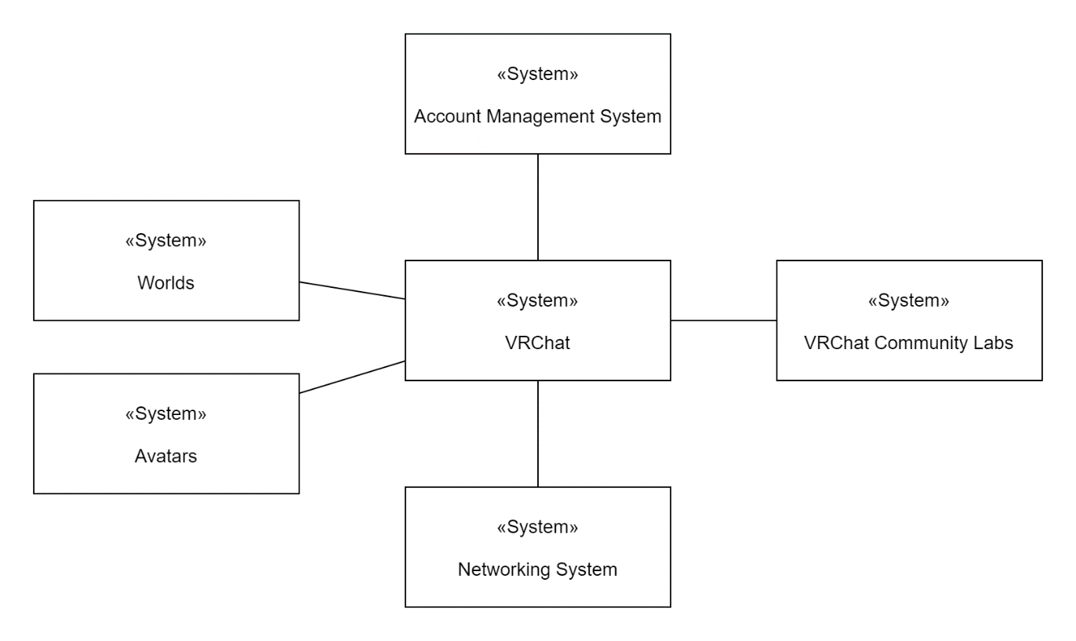[Figure 2] Context Model

### **Process Model**

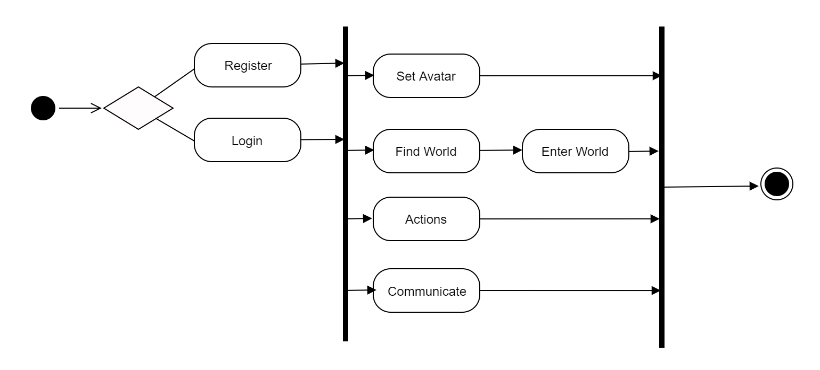

[Figure 3] User Process Model

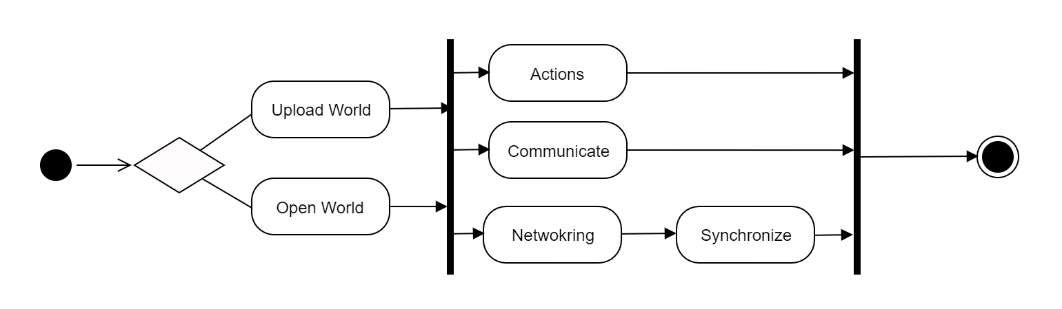

[Figure 4] Administer Process model

### **Interaction Model**

See 3.2.2 Use Case Diagram

## **System Architecture**

This section shows the system architecture using MVC(Model-View-Controller) pattern. In VRChat, the first player who opens the world becomes the administer. There are three concepts in VRChat, variables, events and ownership. The variables are container of values, like numbers, set of colors, and 3D positions. The events are something happens at that moment time. The objects in the world are local in default. This means that the object moves only the person who moves it. To synchronize the object in the world, the object should be the network object. The owner of network object listens to change of the object and synchronize it and send data to other players. The MVC pattern shows users sees the view and do actions. The controller recognizes the actions and send that data to the first player (the owner of network object). The first player changes the objects variables and send data to the controller. The controller updates the objects and shows it to the all of players in the world.

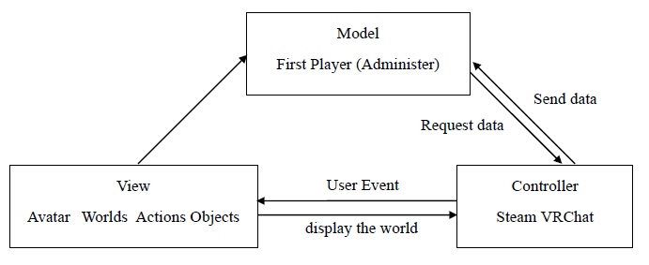[Figure 5] MVC Pattern

## **System Evolution**

In this section, we describe the fundamental assumptions on which the system is based, and any anticipated changes due to hardware evolution, software updates, and so on. This section is useful for system designers as it may help them avoid design decisions that would constrain likely future changes to the system.

### **Limitation and Assumption**

The players who can enter the world at the same time is 80players (40 max limit on the world + 40 friends who can bypass limit). However, VRChat can hold around 20 players and over 20 players it starts to drop the frame. Thus, this world is created for 20 players.

For later, the hardware develops and the software updates well, the world can hold more that 20 players. Then the designers or software engineers should update the number of chairs, visitors’ books, and so on.

### **Evolutions of Hardware**

As hardware develops, the world can hold more than 20 players. The software engineers need to reflect this to increase objects (booths, chairs, and so on) according to the number of players and to additionally increase territory.

1. Supporting information

## **Software Requirement Specification**

This document is written according to the IEEE Recommendation.

## **Document History**

[Table 20] Document History

|  |  |  |  |
| --- | --- | --- | --- |
| Date | Version | Description | Writer |
| 2021/10/28 | 1.0 | Addition of 2 | Soo Namgoong,  Seunggu Kang |
| 2021/10/28 | 1.1 | Make Skeleton | Hyejin Yoon |
| 2021/10/29 | 1.2 | Addition of 3.8, 3.9, 3.10, 3.10.1 | Gyeongun Kang |
| 2021/10/30 | 1.3 | Addition of 3.8.1~3.8.3 | Gyeongun Kang |
| 2021/10/30 | 1.4 | Addition of 1 | Hyejin Yoon |
| 2021/10/30 | 1.5 | Addition of 3.1 | Jeongbok An |
| 2021/10/31 | 1.6 | Addition of 3.3~3.7 | Hyejin Yoon |
| 2021/10/31 | 1.7 | Addition of 3.2 | Yuyeong Seo |
| 2021/10/31 | 1.8 | Addition of 3.2.2, 3.10.2 | Gyeongun Kang |
| 2021/10/31 | 1.9 | Revision of 3.1 | Jeongbok An |
| 2021/10/31 | 1.10 | Revision of 2 | Soo Namgoong,  Seunggu Kang |
| 2021/10/31 | 1.11 | Revision of 3.4 and Revision of Style | Hyejin Yoon |